**RIPHAH INTERNATIONAL**

**UNIVERSITY, ISLAMABAD**



**Lab#3**

**Bachelors of Computer Science – 6th Semester**

**Subject: Artificial Intelligence**

Submitted to: Ms. **Ayesha Akram**

Submitted by: Ayiza Waqar

Sap id : 44529

Date of Submission:

**TASK 1**

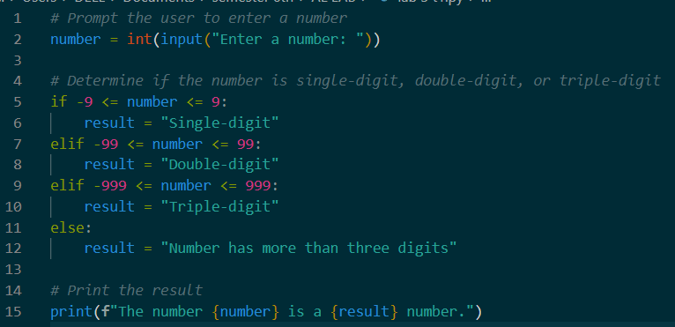

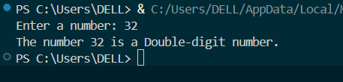

**TASK 2**

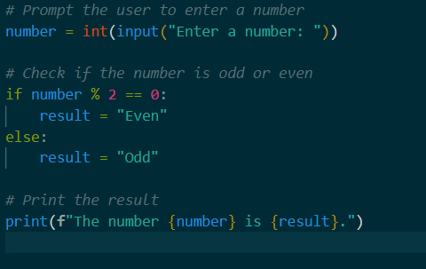

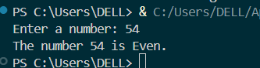

**TASK 3**

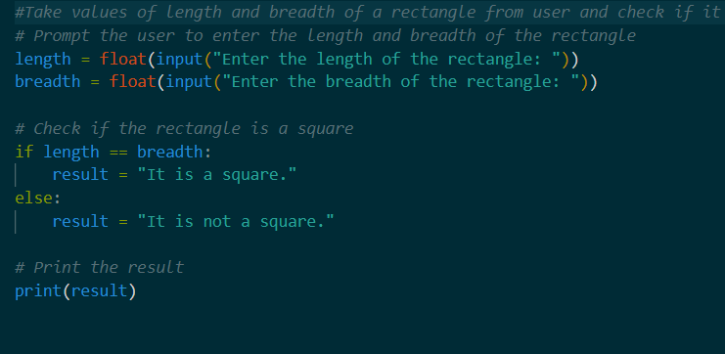

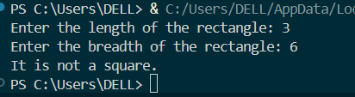

**TASK 4**

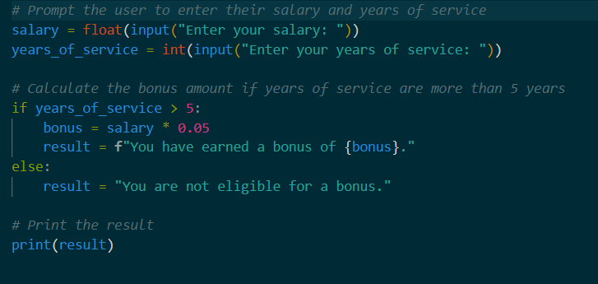

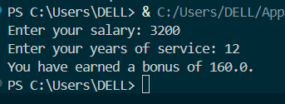

**TASK 5**

